Advanced Chart Techniques and Calculation Insights

Week 4 Task – Sales Performance & Growth Opportunities
Prepared by: [Tumhara Naam]
Course / Module: [Course Ka Naam]
Instructor: [Instructor Ka Naam, agar hai]
Date: 29 August 2026

1. Objective and Approach

1.1 Objective
The objective of this task is to deepen analytical insights by applying advanced charting techniques and calculated fields in Tableau. Using the existing sales dataset, the goal is to:
- Reveal more nuanced patterns in revenue, discounting, delivery performance, and customer satisfaction.
- Demonstrate how advanced visualizations and dynamic calculations can enhance decision-making for the marketing manager.
- Maintain a clear visual narrative that aligns with the Week 2 and Week 3 dashboard and data story.

1.2 Approach
The approach consists of three main steps:
- Research and Selection of Advanced Visualizations
  - Identify at least two advanced chart types that add analytical value.
  - Ensure they integrate well with the existing dashboard context.
- Design and Integration of Calculated Fields
  - Define new calculated metrics that provide deeper insight (e.g., performance flags, month-over-month change).
  - Document the rationale and formula for each calculation.
- Dashboard Layout and Documentation
  - Plan how advanced charts will be laid out and integrated.
  - Describe interactions and how calculations influence interpretation.
  - Produce a comprehensive DOC file that explains technical choices and their impact.

2. Research and Selection of Advanced Visualizations
Two advanced visualization techniques are selected for this task:

2.1 Dual-Axis Chart: Revenue and Discount Over Time
Chart Type: Dual-axis combination chart (bar + line).
Purpose:
- Show Revenue by Month as bars.
- Overlay Avg Discount (%) by Month as a line on a secondary axis.
- Enable the marketing manager to see whether higher revenue periods are associated with heavier discounting.
Why This Is Useful:
- Reveals potential discount dependency:
  - Are revenue peaks driven by deep discounts?
  - Are there months with strong revenue but low discount (good quality growth)?
- Helps evaluate pricing and promotion strategy over time.
Design Details:
- X-axis: Month (from order_date).
- Left Y-axis (primary): Revenue (bars).
- Right Y-axis (secondary): Avg Discount (%) (line).
- Color:
  - Bars: a solid color (e.g., blue).
  - Line: contrasting color (e.g., orange/red) to highlight discount trend.
- Tooltip:
  - Month, Revenue, Avg Discount, Order Count, Avg Rating (optional).

2.2 Heat Map: Region × Product Category Performance
Chart Type: Heat map (highlight table / tiled view).
Purpose:
- Show performance across Region × Product Category combinations.
- Use color intensity to represent a key metric, such as:
  - Avg Customer Rating, or
  - Avg Delivery Days, or
  - Avg Discount (%).
For this plan, we will use Avg Customer Rating as the primary color metric.
Why This Is Useful:
- Quickly highlights which region–category combinations have:
  - High satisfaction (darker green / strong color).
  - Low satisfaction (lighter or red-toned color).
- Makes it easy to spot problem areas that need operational or marketing attention.
Design Details:
- Rows: Product Category.
- Columns: Region.
- Color: Avg Customer Rating (continuous scale from low to high).
- Optional:
  - Size or text labels inside cells to show:
    - Revenue
    - Avg Delivery Days
    - Avg Discount
- Tooltip:
  - Region, Product Category, Revenue, Avg Discount, Avg Delivery Days, Avg Rating, Order Count.

3. Calculated Fields and Table Calculations
This section defines the key calculated fields and table calculations that will be used to enhance the analysis.

3.1 Discount % (Average Discount)
Name: Avg Discount %
Text
AVG([discount])

Formula:

Rationale:
- Provides a simple view of how much discount is being given on average.
- Used in the dual-axis chart to compare with revenue over time.
- Helps identify periods or segments with heavy discounting.
Impact on Analysis:
- Enables the marketing manager to assess whether revenue growth is sustainable or discount-driven.
- Supports pricing and promotion decisions.

3.2 Delivery Performance Flag
Name: Delivery Performance Flag
Formula (example):
Text
IF AVG([delivery_days]) <= 4 THEN "Good"
ELSE "Poor"
END

(Threshold “4 days” can be adjusted based on business expectations.)
Rationale:
- Converts a continuous metric (delivery_days) into a categorical performance indicator.
- Makes it easier to filter and highlight “poor” delivery performance areas.
Impact on Analysis:
- Can be used as a filter: show only “Poor” delivery performance region–category combinations.
- Can drive color coding in charts (e.g., red for Poor, green for Good).
- Simplifies communication with non-technical stakeholders.

3.3 Month-over-Month Revenue % Change
Name: MoM Revenue % Change
Text
// Monthly Revenue
{FIXED DATETRUNC ('month', [order_date]): SUM([revenue])}

Base Calculation:
First, create a calculated field for monthly revenue:

Then, use a table calculation for MoM % change:
Text
// MoM Revenue % Change (table calc)
(ZN(SUM([revenue])) - LOOKUP(ZN(SUM([revenue])), -1))
/ ABS(LOOKUP(ZN(SUM([revenue])), -1))

Set the computation to compute using Table (Across) or Pane (Across) depending on the view.
Rationale:
- Shows how revenue is changing month over month in percentage terms.
- Highlights growth or decline patterns more clearly than raw revenue alone.
Impact on Analysis:
- Can be added as a tooltip or label in the dual-axis chart.
- Helps identify sudden drops or spikes in revenue.
- Supports more dynamic storytelling (e.g., “Revenue grew by 12% MoM in June”).

3.4 (Optional) Profit and Margin (If Cost Data Is Added Later)
If a cost_per_unit field is added in the future, you can define:
Profit:
Text
SUM(([unit_price] - [cost_per_unit]) * [quantity])

Margin %:
Text
SUM(([unit_price] - [cost_per_unit]) * [quantity])/ SUM([unit_price] * [quantity]}

For now, these are noted as future enhancements if cost data becomes available.

4. Dashboard Layout and Integration Plan
This section outlines how the advanced visualizations will be integrated into a dashboard context.

4.1 Dashboard Structure
The advanced charts will be part of an enhanced version of the Week 2/3 dashboard. The layout will include:
- Header & Global Filters
  - Title: “Sales Performance & Growth Opportunities – Advanced Analytics”
  - Filters:
    - Relative date (Last 3/6/12 months, YTD)
    - Region (multi-select)
    - Product Category (multi-select)
    - Payment Method (multi-select)

- KPI Summary (Optional in This View)
  - Total Revenue
  - Avg Order Value
  - Avg Discount
  - Avg Delivery Days
  - Avg Customer Rating

- Dual-Axis Chart: Revenue + Avg Discount Over Time
  - Full-width chart below KPIs.
  - Serves as the primary time-based insight.

- Heat Map: Region × Product Category (Avg Rating)
  - Placed below the dual-axis chart.
  - Provides a quick “performance map” across segments.

- Supporting Views (Optional)
  - Detail table with Delivery Performance Flag.
  - Bar charts for revenue by region/category (from earlier weeks).
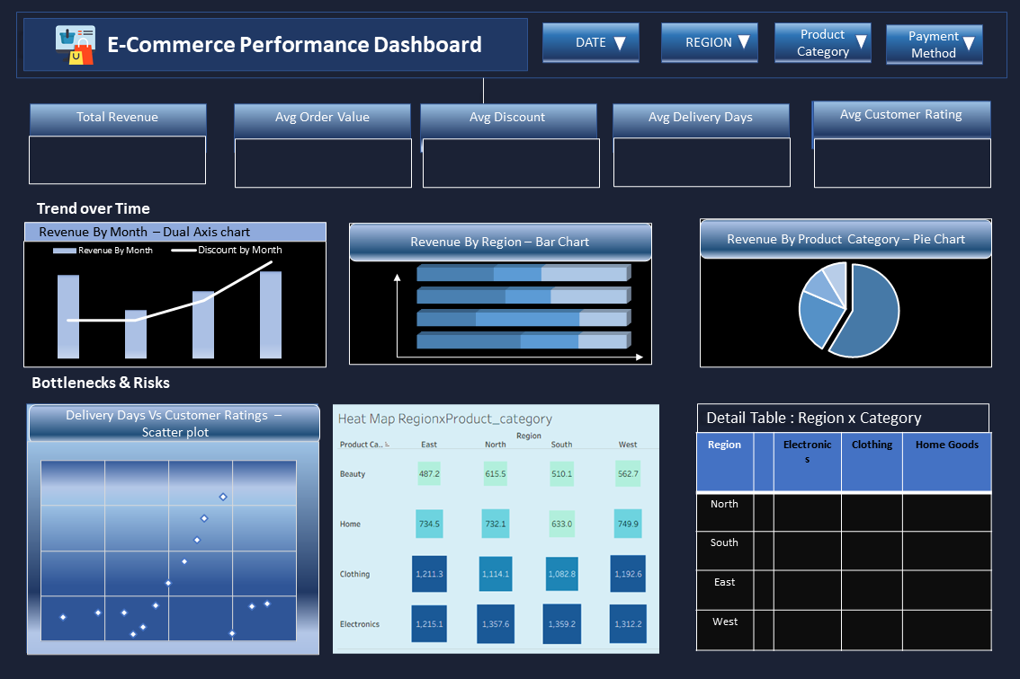
The figure above illustrates the planned arrangement of visualizations described above. The dual-axis chart occupies the top full-width band, followed by the heat map, with supporting views and detail tables below.

4.2 Interaction Between Visualizations
Interactions:
- Global Filters:
  - Apply to all views (dual-axis chart, heat map, tables).

- Click on Heat Map Cell:
  - Filters the dual-axis chart and any detail tables to the selected Region × Product Category.
  - Helps answer: “How do revenue and discount trends look for this specific combination?”

- Hover on Dual-Axis Chart:
  - Tooltip shows: Month, Revenue, Avg Discount, MoM Revenue % Change, Order Count, Avg Rating.

- Delivery Performance Flag Filter:
  - A quick filter to show only “Poor” delivery performance combinations in the heat map and table.
Narrative Support:
- Text captions or dashboard titles will explain:
  - Why dual-axis is used (to compare revenue and discount trends).
  - How to interpret the heat map (color = Avg Rating, darker = better).
  - How calculated fields like Delivery Performance Flag simplify decision-making.

5. Design Rationale and Intended Impact

5.1 Innovative Application of Advanced Charting Techniques
- Dual-axis chart combines volume (revenue) and pricing behavior (discount) in one view, revealing relationships that separate charts would hide.
- Heat map transforms a traditional crosstab into an intuitive visual performance map, allowing quick identification of high/low satisfaction areas.

5.2 Clarity and Correctness of Calculated Fields
- All calculated fields are clearly defined with formulas and rationale.
- Avg Discount % directly supports the dual-axis chart.
- Delivery Performance Flag simplifies complex delivery data into an actionable category.
- MoM Revenue % Change adds a dynamic growth perspective to static revenue numbers.

5.3 Quality and Thoroughness of Documentation
- This DOC file details:
  - Which advanced charts are used and why ?
  - Exact formulas for key calculations.
  - How these elements integrate into the dashboard.
  - How interactions support the narrative.

5.4 Overall Technical Depth and User-Centered Design
- Technical depth is demonstrated through:
  - Dual-axis design.
  - Use of table calculations (MoM % change).
  - Logical flags for performance categorization.
- User-centered design is maintained by:
  - Keeping interpretations simple (e.g., Good/Poor flag).
  - Using color and layout to guide attention.
  - Ensuring that every advanced element answers a clear business question.

6. Implementation Notes (Brief)
- Tool: Tableau Desktop.
- Data Source: Same CSV/Excel as Weeks 2–3:
  - order_id
  - order_date
  - customer_id
  - product_category
  - region
  - quantity
  - unit_price
  - discount
  - payment_method
  - delivery_days
  - customer_rating
  - revenue
- Refresh Frequency: To be defined (e.g., weekly or monthly).
- Performance Considerations:
  - Use aggregations for charts.
  - Limit detail tables to filtered subsets if data grows large.
  - Optimize calculations (e.g., avoid unnecessary FIXED LODs if not needed).

